Byron’s Story

The pilot still resonates with me years after its debut on the HUB network. In that first episode, Twilight Sparkle was totally devoted to her studies, thinking of everyone in her life as a distraction and going to great lengths to keep them at hoof's length. Boy, can I relate. I'm an introvert at heart, and I don't socialize much. I can't really explain why... it could be the result of my ASD, or just a natural aversion to social situations. Whatever the reason, I'm sure that my reluctance to be around other people has cost me opportunities, but it hasn't stopped my friends from coming through for me when I needed them most.
Last year, I came down with a severe case of pancreatitus, a digestive disease that's often painful and occasionally fatal. The disease nearly claimed my life twice, and kept me from both my online art galleries and my favorite web sites for months. When I was finally well enough to return home from the hospital, a funny thing happened. I not only got the expected "get well soon" cards from family members, but an outpouring of concern, well wishes, and even gifts from my online friends as well. I didn't expect that support, and I may not have even deserved it, but it was there for me, and I'll always be thankful for it.
That's the magic of friendship... its surprising generosity. You'd expect to only get out of it what you put into it, but your friends have a habit of reaching beyond your expectations. If you give a little, you'll get a lot more in return. With this in mind, it's worth taking a break from whatever seems important at the moment and spending some time with those close to you. Friendships don't always work out, and the people you love may grow distant with time and differences of opinion, but showing your friends how much they mean to you is always worth the effort.

***

Boom’s Letter

Dear Fluttershy and Rarity,
When I first discovered your show existed, I was in incredible pain. I had an awful back problem which caused me pain to the point of being unable to walk. Because of this I had to take heavy duty pain killers and I thought I loved your show only because I was high as a kite. But the next day I was back to normal and I continued watching. I have not stopped since.

After watching your show I really wanted some pony dolls. When I was little, I was bullied. I felt that if I liked ponies, my bulling problem would get worse. So I wanted to keep quiet about buying pony dolls. I was still in pain at this point, but still I went and proudly bought my two favorite ponies: Fluttershy and Rarity. I brought them home with me and my dad was alright with it. He thought it was funny.

So, during my bed ridden days I watched ponies with you two by my side. I drew pictures and wanted to be totally immersed in the land of Equestria. After a while, I physically healed but sadly I became mentally unstable. About a month or two later I lost someone who I thought was someone I needed. I did something incredibly stupid. I tried to end my life. I was sent to the hospital, where I stayed about two weeks. During those two weeks your dolls were by my side, whether crying to my nurse about the one I lost, or in those lonely days in the main hall. I thank you so much for helping me.

***
Somnii’s Story

My Little Pony has greatly influenced my life, the greatest amount of influence I believe has come from observing the character Twilight Sparkle. I adored learning, much like Twilight, but also lacked any experience with friendship, or even socializing for that matter. A student one day in my class came up and sat next to me, he invited me into his group. As might have been expected I did my best to stay away. However this student dedicated to his cause then continued to sit by me in class and during lunches constantly offering his friendship to me, until eventually I conceded. Like Twilight I did not care much for friendship, most likely for the fact that like her, I had no experience of it.
This student one day came to class with a lanyard with the Mane 6 on it. Curiosity always getting the better of me I asked him about it and he patiently explained it to me. That summer ,I saw my first episode and there was nothing that could compare to how much I was surprised. Following this they eventually played the first episode of the series. Watching Twilight behave exactly the way I had for years shook me to my core, and then to see that someone could genuinely care, like that student had, about her, brought tears to my eyes.
***
Adam’s Story
My name is Adam, and I live in Canada. My overall favorite character is Twilight Sparkle, though I am a fan of the entire mane 6 (including Spike).
I only started watching My Little Pony: Friendship is Magic a few months ago. Before then I thought it was rather odd, and especially odd that so many people of all ages and genders liked it so much. But then I realized that some of my best friends were into it. I thought about watching the first episode. My friends were into plenty of other things I liked, so maybe My Little Pony would be something I liked as well. So I watched the first episode. Then I watched the second, and the third, and the forth, and so on. I have been a fan ever since then.
My Little Pony: Friendship is Magic had inspired me to never judge a book by its cover. Also, it’s helpful to try things your friends like. Even if you try something and find that it’s not for you, just the act of trying will bring you closer to your friends.
***
Line Monkey’s Story
In June of 2013, I was in a very bad car accident. Without realizing the severity of my injuries, I volunteered at Everfree Northwest 2013 as part of the Security team. The last day of the convention was spent in a wheelchair, because I could not walk without pain.
The day after the convention, I went to my doctor. Several tests were run, and it was discovered that I had multiple micro-fractures in my lower spine, several torn and stretched ligaments and tendons, and nerve damage which made it impossible to hold my own weight on my right leg. This meant that I would be wheelchair-bound for most of the rest of my life. I am a mother, with four children, and my husband and I survive on his VA disability income. We don't have insurance, or any way to pay for a wheelchair.
So I took it to the community.
Within 4 days, my GoFundMe had reached its goal, and I am now the proud owner of a power-chair.
I wouldn't have been able to be as mobile as I am without the generosity and kindness of the Brony Community. Thank you.
***
Christian S.’s Story
Depression has a way of getting to you. It can make you feel down, despite how hard you try to convince yourself you matter. I have had depression since the 4th grade and it's been really tough.

I can say that My Little Pony Friendship is magic and the brony community has helped me in a way I can never forget or can never express my gratitude enough. The community surrounded me with support and friendship that I can easily say has helped me cope with my depression, and finally, with each passing day that I am a member of a great community, I feel like I'm getting better, that my depression is slowly fading away.

***

Spencer’s Story

I really like Twilight, who is hard working and intelligent. I was a lot like her first phase, working hard and feeling bad if my work was not accomplished. Then like her, I learned to let go and live a little. While my writing is now slower, I am now more happier because I can do many other things that I enjoy. We share a fear of failing, like her nightmare sequence during the Crystal Heart Storyline. I too fear of not being good enough and abandoned. Though I know Twilight is an amazing pony that is intelligent, focused and determined, which are traits that I hope I possess too.

***

Tanko D.’s Story
I love MLP and I love being a Brony. I make note of the moral of each episode and try to incorporate it into my attitude/daily life thus making me a nicer and better person. iI used to be really negative but the show has really turned my attitude around and now I approach each day of my life with a positive attitude :)

***

Dustin A.’s Story
I've always had a problem making friends because of my autism and my Tourette's. If my random speech pattern didn't scare people away, then my twitches did. But amongst the MLP fan base, I found friends for the first time, and they all love me for who I am.

***

Jason M.’s Story
It's amazing how a show like My Little Pony can take someone who is so introverted and shy into an outgoing and wacky person. I was born three and a half months premature and have cerebral palsy on the right hand, foot, and no sight in the right eye. I'm also low vision in the left. I started watching the show in mid 2011, going through the motions of "OH man why am I watching this!?" the first few episodes, until I gradually watched everything there was. One day, I happened upon Celestia Radio-- a radio station for a bunch of pony music that the fandom was making. I started listening and enjoying the music and the DJ running his little show and thought "this could use more silly ads!"

I became a DJ myself after a few months, and now I'm here today, spreading ponies throughout the world as DJ Squirrel and running DJ booths and panels at cons. I've made many new friends and met people I never dreamed of meeting, like John Delancie, from Star Trek. The magic of friendship really does extend to all of us when we know where to look.

***

Hannah S.’s Story
In grade 2, I was diagnosed with ADHD. I was weird, awkward and I was not that good at making friends. I didn't try to make any at school, horseback riding or Ringette, and figured if anyone wanted to be my friend, they would tell me. But in grade 5, I met my 2 best friends, Greg and Victoria, but it didn't last for long because I moved away when grade 5 was done. Greg and Victoria helped my discover how magical friendship actually is, and I longed to make another relationship like I had with them, but I didn't know how. I started feeling lonely and I was bullied because I was a loner and outsider, But then I discovered MLP:FiM, and things turned around QUICK. I re-discovered the magic of friendship, and was inspired to try harder at learning how to make friends. I watched how the Mane 6 treated each other, how they resolved friendship problems, and lots more!

At the beginning of grade 8, I met a boy named Hastings, like me, who was bullied and was ot good at making friends. I was watching videos on the bus, and he asked if he could watch with me. He quickly became interested and wanted to see what the show was like. One episode and he was hooked! We became friends over a shared interest, MLP. We discussed our favorite characters (He likes Fluttershy and Pinkie) and watched our favorite videos (He LOVES the Ponies The Anthology series and Rainbow factory SFM PMV). Together, we learned the importance of friendship, and helped each other make new friends!

***

Donnie S.’s Story and Letter
I'm a teen guy with autism. I've grown up in towns where people don't have the first clue about it, and... in the past, people have discriminated against me. I made it into a high school that has students with disabilities like mine, but I still felt like a loner. I made a friend who talked about My Little Pony, and I couldn't believe what I was hearing. I decided to watch the show, and turned away, but then I watched a few more episodes, and I was perplexed by one character then another, but the show really inspired me when I heard all the lessons every pony learned at the end of an episode, and I look forward to hearing spike take letters. My Little Pony Friendship Is Magic inspired me to learn more about my autism, and be more confident in it, as well as myself. Regardless of what anyone says unless, it is positive.
Dear Rainbow Dash:
Hello Rainbow, my name is Donnie, and I think you are the most awesome pony ever. I consider myself an athlete, and I enjoy competing against other opponents in a race. I'm a fast runner, and I enjoy a good challenge when it presents itself, but I enjoy it the most when I'm neck to neck at the finish line. I get a rush of adrenaline during those moments. Rainbow, you have been an inspiration to me. I always knew that I had many skills, and strengths like yours, but I used to be doubtful when using them. Especially when things did not work out the way I thought they would. I've seen you do awesome things like pull off a Sonic Rainboom at the Best Young Flyer competition even with the extra stress from Rarity. I thought to myself, "She saved the day with her agility...Maybe I should test my skills a bit more."

***

Brent A.’s Story

To me My Little Pony is what makes me smile when I'm sad. My days were beginning to feel a chore, but then I got so bored I did something odd. I started watching the show we all know and love. Not only did it make me happier, it changed my overall confidence.

When I was younger I was really shy and an outcast, but now I can walk right up to someone and tell them what I think. I have gained so much from this show, and did not have to sacrifice anything.
Happiness can come from unexpected places.

***

Travis R.’s Story

I've been depressed for most of my life. I don't have that many irl friends, and I have Aspergers which makes socialization difficult. For the longest time, I felt really alone and worthless. But In 2010, I discovered MLP. It was one of the most wondrous things I've ever discovered. It sounds weird, but it makes me really happy. I still get depressed a lot of the time but usually some ponies can fix that. I just wish I could see the awesome people that made that show and thank them for all of it.

***

Tamina G’s Story

My sister and I love to watch My Little Pony together. She has spinal muscular atrophy, and was so happy to see a pony character in the trading episode that had a wheelchair like her, and even happier that the character was not part of a "lesson" episode. She was even happier to fins that the character was inspired and created by a fan with spinal muscular atrophy and now we have lots of fun coming up with stories about our own character. She says she wants to become a writer for a children's show when she grows up now!

***

Silver Stars’ Letter
Dear Fluttershy,

I have been diagnosed with Social Anxiety. I can imagine how you felt nervous leaving your safe place and going on stage. Dealing with anxiety-- it's hard. Really hard. It's not about being judged on stage, it's about being judged everywhere you go. You feel constantly watched and judged for whatever you're doing. Seeing you work together with your friends on this made me see how far I've come in tackling this phobia and made me realize that I'm not alone in facing my fears.

***

Keelan B’s Story
I was always a shy kid and having autism didn't help. It wasn't until I started watching MLP that I started to become a bit more social and all thanks to a shy Pegasus named Fluttershy.

***

Melissa B’s Story

I am a survivor of trauma. I have PTSD. This show has actually been part of my healing process. My Little Pony teaches so much about friendship--what good friends do and what bad friends do, how to interact with people like you that are also unlike you at the same time. There was something there, something that I needed so badly as a child. I didn’t just need to feel less alone…I needed a safe message, no matter how “uncool” or pedantic.

It is so liberating to see these lessons— these messages no one ever gave me— right here, in a non-threatening, non-serious form. Sometimes it hurts to always be hurting. Sometimes I need this silliness, the immaturity, so that I can laugh at myself and laugh at how I am still here.

***

Clara S.’s Story

The worst part of letting anyone know I have a disability is that people immediately treat me differently, like I am a child or something less than a person. That's why I was happy to see a show that I watch with my baby sister demonstrate that, like Scootaloo, I may be different and I may not be able to do something everyone else can and I may not ever be able to do the same things others can-- but I can definitely be me, and those that love and care about me will always be there for me.

***

Thomas C.’s Story

I watch My Little Pony with my daughter. When I saw an episode with Applejack working herself to exhaustion because she took on a huge job and then didn't ask for help when she needed it, I laughed. Then I realized it was something I did way too often myself. Now I've gotten lots better at dividing jobs up into smaller parts and asking for help when I need it.

***

Pea Pod’s Story
This particular generation of My Little Pony has brought me closer to my younger cousins, who really needed (and still need) friendship and kindness after their father passed away. We just didn’t connect with each other until we were channel-surfing one day and caught the tail-end of an episode of Friendship is Magic. It was like a switch went off, and we all started talking — me about how I used to watch the second and third generations as a kid and them about how much they liked that every character in the cast were friends besides how different they were in personality. By the time the conversation wound down, we’d ended up just chatting for almost two hours straight. That was what really helped us all open up to each other.

***

Tara C.’s Story

Having always suffered from low-esteem, Rarity's conflict in the Nightmare Rarity arc really spoke to me. To quote the fashionista herself, "I thought you'd forget me if I stopped being fabulous." Seeing how Rarity's friends never gave up on her, even after she did something she regretted made me think that maybe I am worth it to my own friends. Thank you, MLP, for showing me that everypony is irreplaceable to her dearest friends.

***

Bethany D.’s Story

I have Aspergers. I avoided talking to people so I didn't accidentally make a fool of myself or upset them. I watched My Little Pony out of curiosity after seeing it all over the place online, and I instantly related to Fluttershy. Awkward, barely able to talk to people, but in her heart she only wanted good things for the people around her. It made me realize that perhaps I'm not entirely useless, maybe people wouldn't actually mind if I spoke up more, even if I did mess up a few times.

Eventually, I forced myself to come out of my shell. I made myself speak to at least one person a day, be it just a small compliment on their outfit or their hair, and eventually I got used to it. Now I'm 19 and at university, and I actually have a group of friends who don't even seem to notice my disability unless I directly bring attention to it, who didn't even realize I had it until I told them. Without that little yellow pony, I don't know where I would be today, but it wouldn't be here.

***

Grace R.’s Story

In August of 2013, my grandmother passed away. It seemed unfair because I had talked to her the day before. I was in denial for a while until one day I had to go back to the United States (I was in Korea). I wasn't used to actually watching tv because I had always used etflix. So I used netflix a lot. I started to rewatch all of my favorite shows. Eventually, I ran out of shows to binge watch. I then remembered MLP:FiM.

After I watched the episodes, I realized that I would get through this rough time with the help of my friends. So I skyped with them (they live in Korea and I to my school) every weekend. That's how MLP changed my life.

***

Chaseman’s Story
I never could make friends, eye contact, hold conversations, etc. This show has benefited me by teaching me social skills that I could never pick up on in real life from real people. Everything from handling a situation to reading facial expressions. Now that I have learned these through the show, and received “Brain Training” I am light years beyond where I was a long time ago, I do still find it uncomfortable to talk to strangers or family I haven’t seen in a very long time, but I can bring myself to do it now.

***

Haystack Lifter’s Story

MLP helped me through the roughest experience of my life. On top of crippling anxiety I’ve been going through a rough withdrawal from a long time painkiller addiction. Every time I felt tempted to give in, I’d watch an episode of My Little Pony. On top of watching episodes I keep a miniature Pinkie Pie in my pocket for support when a friend isn’t near. I can happily say I’ve been attending Narcotics Anonymous, I've been drug free for a year and for the first time in my life I truly feel like myself and remember to "smile, smile, smile".

***

Lisa T.’s Story

MLP:FIM helped me get out of a dark place. I had gone through personal loss and was diagnosed with depression not soon after. Even on medication, motivation became really hard to summon sometimes... but I found that rewarding myself with an episode of the cartoon at the end of the day helped me a whole lot. I didn’t have much good going on in my life, but I did have colorful ponies to turn to every Saturday morning!

***

Robert K.’s Story
For a long time, I didn't see why anyone wanted friends. I've been been teased for my mobility aids, and the teasing really hurt. I didn't want anything to do with people and I planned on moving far away and living alone. I didn't want love and I didn't even want friendship. I didn't want anyone in my life. I started watching MLP FIM because it was waiting for something else on TV, and was surprised and charmed. From there, I caught up on all the episode I've missed. I identify a lot with Twilight's journey to reach out and make friends and have done so, first in joining an anime club, and then reaching out to other activities. I've found my own "Mane Six" friends, showing me that truly "Friendship is magic". Twilight inspires me to find good people in the world.

***

Tiara Shine’s Story
Pinkie Pie's happy, pranky and social side reminds me of my boyfriend. I'm probably more like Fluttershy: quiet, shy but ready to stand up for my friends. Just last week, I was having a really horrible day, feeling incapacitated with gender dysphoria & triggered panic attacks. Watching My Little Pony helped me hold on until my roommate came home.

***

Selina R.’s Story
Like Twilight, I didn't see the importance of developing friend. I'm a wheelchair user and I've always had a lot of body image issues, so this was an easy defense against uncaring society. I started to branch out a few years ago, though, when I heard about a new my little pony. Through the show I found fan sites, through those sites I found tumblrs, and through there I found groups where I could confide in other people my age who were going through similar things, and build friendships that were real and lasting, despite being online. Through my online friends my confidence grew, and it was through a cartoon about friendship that I found some of my truest and most faithful friends!

***
Nathan K.’s Letter

Dear Derpy,

I was born with Aspergers. All of my life, it has seemed impossible to fit in. I find myself uncomfortable around new people, and I it is extremely difficult to talk to anyone. Then I discovered My Little Pony: Friendship is Magic. The characters, stories, and life lessons really inspired me and filled me with hope. But It wasn't until a gray pony with a yellow mane and tail and bubbles for a cutie mark flew into my life that I felt complete. Like me, you were made fun of and cast aside because of how you acted. I felt like I was looking in a mirror. You were going through the exact same things that I was Derpy, but you still trotted on.

You have inspired me to stay true to myself, and to not let the words or actions of others keep me down. Because of you, I was able to meet other Bronies, and even become a member of a Brony group called DC Bronies. Even when I still get sad, all I have to do is think of you and feel stronger. Thank you so much.

***

Megan R.’s Letter

Dear Pinkie Pie,

You remind me so much of myself. The way you smile and try to cheer up everybody even if it's at a cost to yourself. The way you wish to help others the second they look upset or sad, even if they do think you’re a little bit crazy. I just want to say thank you. “It’s true some days are dark and lonely, and maybe you feel sad, but Pinkie will be there to show you that it isn’t that bad.” - Pinkie Pie (Smile Song)

Thank you for showing a girl with chronic depression, who also would cut herself nightly that there is a bright side to life, that you don’t have to make out the world to be a dark place, that the world is also full of kind people who love to see you everyday. When you invited your friends to a party, and they all couldn’t go, you got sad, your mane went dead straight instead of the fluffy pink mane that everyone is used to seeing. That’s how I would always feel coming home from the end of a long day. Sad, upset, feeling that your friends don’t really like you at all. However I found out that it wasn’t true in the end, just like you did. Thank you Pinkie, and all the colorful ponies on the show to help show a girl the world is not such a bad place.

***

Tia O.’s Story

I have autism and cerebral palsy. My autism means I have very intense interests, for which I am often bullied. MLP, and particularly its fandom, has helped me to become more comfortable with my various quirks and in my own skin.

***

Per N.’s Story

Before I started watching My Little Pony, I really felt as if life was kinda meaningless. I have been a constant victim of bullying all my life because of my appearance. When I found MLP, it felt as if none of that mattered anymore. Because of MLP, I meet friends and people I really like to talk with and the show itself has become something I can turn to when it feels as if life is pointless. MLP has made a big change in my life-- if it hadn't been for MLP I don't think I would ever have smiled another day in my life. But now thanks to MLP I smile as often as I can.

***

Eric L.’s Story

I came to Friendship is Magic seeking relief from my life. Having lost my vision recently after struggling with visual impairments all my life, an abusive childhood, and experiencing severe depression, with no friends in high school, I needed an outlet. I had heard of the show on the Internet, and figured it would be worth a laugh at worst, so I watched the pilot. Although I can't see the characters or animation, the positive atmosphere and friendly voices of the characters gave me a small relief. So I kept watching and saw both seasons at the time in a week.

Missing the comfort, I found a forum of fans and soon joined them in pony discussion. It had become such a regular thing that I stayed with them and grew to know every member. And to this day 2 years later, I count many as personal friends. They described details of the animation I miss, and although I would love to watch it myself and sad I can't see the fan art, still their help is enough. With friends to encourage me and season 3 to look forward to, I had enough determination to turn my failed semester around and graduated the next year.

The journey is still not easy, my depression persists and it is rare to smile, but I have not given up. Now in therapy and taking medication with ponies and friends to keep me going, I hope to be happy someday. Baby steps, as Fluttershy would say.

***

Alicia R.’s Story
Due to an autoimmune disorder, I'm in constant pain. Sometimes it's manageable and I can draw, watch videos, and do other light activity and then sometimes it's not. So now when I have trouble walking, I remember what it was like to run, and I thank Pinkie Pie and all my friends for helping me find a way to fly, as shown in this picture, “Taking Flight Again”:

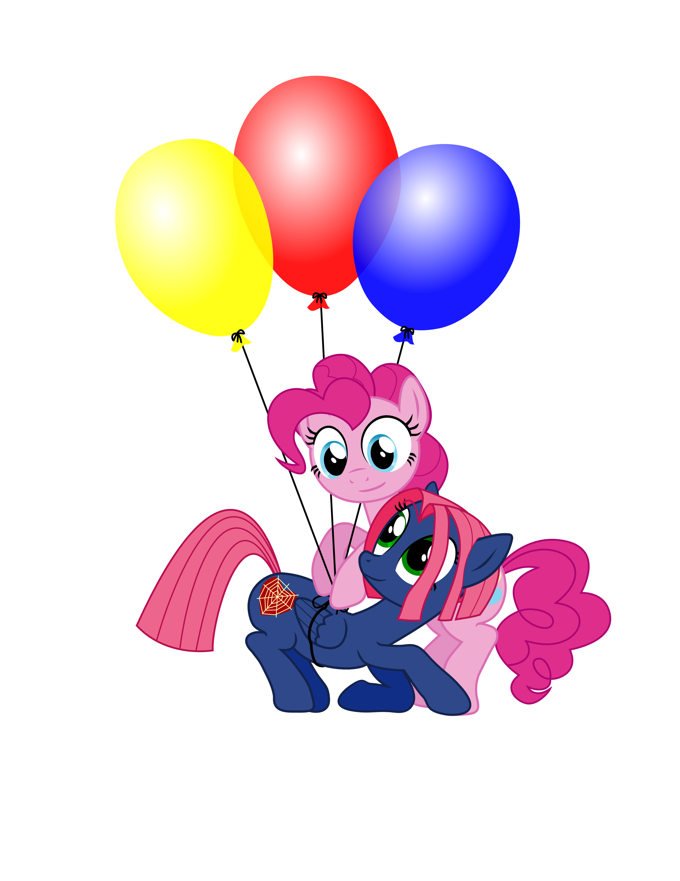

Picture: Pinkie Pie is helping another pony (an O.C. Pegasus) “take flight” by tying helium-filled balloons to her. The balloons are yellow, red and blue. The pony receiving assistance is purple with pink hair, green eyes and its cutie mark is a red heart covered in a yellow spider web. The O.C. is smiling at Pinkie Pie.

***
Lizbeth H.’s Story

As always I would cry myself to sleep and talk to darkness, telling it my troubles at school the bullying for that matter it would always pay attention .Of course the only other people - no scratch that, the only other ponies that listened were in the My Little Pony .The characters gave me a chance to smile more than actual people could, but the only one I found relatable out of all the ponies was princess Luna. Luna actually put her hoof out to help. That's why I always talked to the darkness; it helped me. That's why I looked at the moon early in the night. She gave me a reason to smile

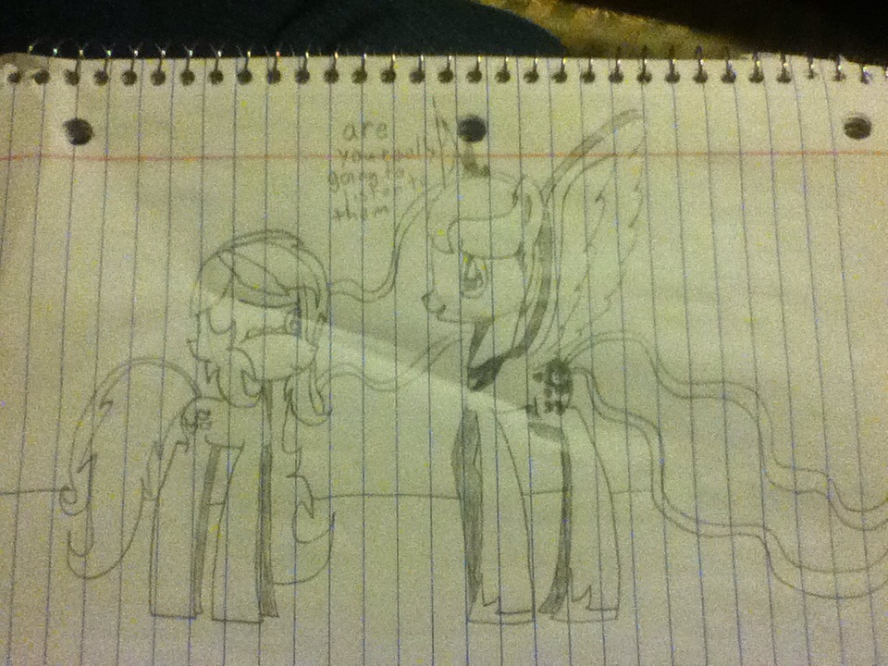

Picture: The author’s O.C. is positioned left and Princess Luna is on the right facing her. There is a caption above both ponies that states: “Are you really going to listen to them.” The O.C. appears to have teardrops streaming from her eyes.

****
Paolo M.’s Story

I joined the fandom in late 2012, around the season 2-3 hiatus. During that time, I was depressed, due to everyone around me not listening to me & everyone making fun of my dyslexia. I watched My Little Pony as a gag.

***

Matthew Palumbo’s Letter

Dear Spike:
Allow me to introduce myself. My name is Matthew Palumbo and I am a human who has been a fan of the adventures you and Twilight Sparkle have shared since leaving Canterlot.
The reason I write you is to share how I feel you and I are kindred spirits. Two individuals who, through no fault of our own, have had to cope and adapt to many things that so many others have not. Situations that often go unnoticed, unrecognized, and unrewarded.
You, like me, are a faithful worker who strives to do the best he can for those who he admires and looks up to. Unfortunately, what we do never seems to be enough. We are continuously left out of important activities, expected to perform according to how others expect us to with our own suggestions falling largely upon deaf ears, and made to feel more like a “Nice to have around Assistant” instead of as a valued part of the team.
You and I also share in a strong desire to find out “Who we are” and “What we are supposed to be” due to how different we are from those around us. Where you are a dragon in a world dominated by ponies, I am a human who is mislabeled by my fellow kind as being less capable of doing things just because of a disability I was born with. Also, like you, I largely work around women. Or, in your case, fillies and mares. All of which treat me like a child who is only good enough to do work they’d rather not do themselves.
It is nice to feel useful, as I’m sure you’ll agree, but I know you, like me, would like to know we are seen as more than just someone who is nice to have around, to know what we do is truly valued and that we are very capable of doing far more than we are given the chance to do. We'd both llike to show everyone that, despite our differences, we are amazing, worthy of respect, and are capable of great contributions to our respective worlds. Thank you for taking the time to read my letter to you, Spike. I truly feel you and I are one and the same and wish to offer you a hug of support. I want you to know you are not the only one who is marginalized, left out, and treated as more of a “Convenience” than as an equal.
Be well, Spike. Know I will, as I know you will, too, do my best to show everyone / every pony that our differences don’t make us any less important. You may not have wings and, soon, I will not have eyes. However, we both are intelligent individuals who, through perseverance, can overcome all the prejudice and ignorance that is thrown our way.
P.S. I like to wear aprons, too. :)

***
Ben's Letter

Dear Princess Luna,
My name is Ben, though I am known in other social mediums by the name Bengeta. First off, I have to say that it is a great honor and privilege to write this letter, your highness. You are a powerful yet gentle ruler, and your powers of the night are mystifying to many, especially myself.
I feel that I identify with you in many ways. I've been a night owl from a young age, but as I've gotten older, I've grown to better appreciate its beauty. Your sister's sun is a wondrous sight to behold, but I find myself drawn more deeply to your moon and stars. They give me a great sense of wonder, and of peace, whenever I stand alone at night and gaze up at the sky. I also know, however, that the night can be a very frightening and dangerous place, filled with perils unseen by day. In light of these things, I possess renewed energy and joy at night, but I am also often alone when the moon shines in the sky. As such, I find myself more easily influenced by the evil within me. Temptation, loneliness, anger; all these things pry at my soul and try to distract me from what is good and pure. In this way I identify with you the most; you are a kind-hearted and strong princess, but it was the power of jealousy and anger which brought you down the path of evil, turning you into Nightmare Moon and clothing you in a mantle of darkness, until you were able to break free of its unholy chains. While I have no such magical abilities, I feel that I understand your struggle with the temptation to let the night overtake you, and turn you into something you're not. Know that I struggle with this same conflict, your highness, and that I think of you whenever I gaze at the moon. I wish you well. Perhaps we will one day meet in the realm of our dreams.

***
Alora’s Story

I was born with a disease called Muscular Dystrophy, it slowly eats at my muscles, and has no known cure. I have been in a wheelchair all of my life, but was not completely wheelchair-bound until I was 14. I used to play with My Little Pony toys when I was little but did not discover the latest generation until the summer of 2012.

At that point in my life I had just gotten out of a foster home, and had begun living with my grandfather. When my grandfather begun showing signs of Alzheimer's, Pony became my escape when I couldn't physically get away. Since then, Pony has helped me make friends who like the show too, I even joined my high schools after school MLP Club.

When school started last year, I got very sick. I had gotten double pneumonia, and was in the hospital for a couple weeks. A week after being released, I went back to the hospital for another month with the flu. Luckily I was able to go home before Season 4 started in late November. Unfortunately, in March, I had to be rushed back to the hospital a few weeks after my 17th birthday. My lungs had collapsed again, and I was unable to breathe on my own anymore. The doctors decided it would be best to place me into a medically-induced coma until I was stable enough to be woken up.

When I woke up, I had 6 or 7 tubes coming out of my mouth that went down my throat, one was in between my vocal chords, so I couldn't talk, or make any noise. After three weeks, they did a surgery to insert a breathing tube in my throat called a trach.

During that time I knew I was missing quite a few new pony episodes, and I couldn't do anything about it until after the trach was placed so I could watch them online since the hospital didn't have the channel that plays pony. Being able to catch up made me feel alot better. Fluttershy is my favorite pony because she reminds me alot of myself.

When The Make-A-Wish foundation threw me a party a few months ago, a got a new Ipad with a recorded message from Fluttershy and Pinkie Pie, straight from Andrea Libman herself! My Little Pony has truly made rough times, and my recovery, so much easier.

